ASG-AUTO SCALING GROUP

Task Title
Design and Deploy a Highly Available Web Application Architecture

Objective
To design and deploy a secure, scalable, and monitored AWS infrastructure using VPC, public/private subnets, EC2, NAT Gateway, Application Load Balancer, Auto Scaling, logging, and monitoring services.
Step-by-Step Implementation With Evidence
Create VPC
- Console Path:
VPC → Create VPC
- Configuration:
Name: any name
CIDR: 10.0.0.0/16
- Explanation:
Creates an isolated network for resources.
1. Create one VPC in N. Virginia region.
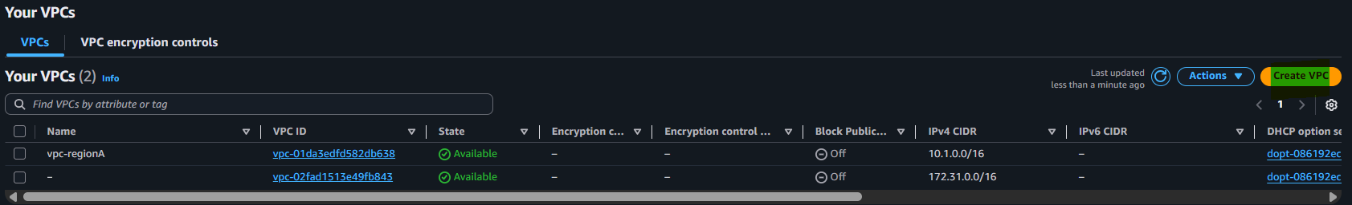
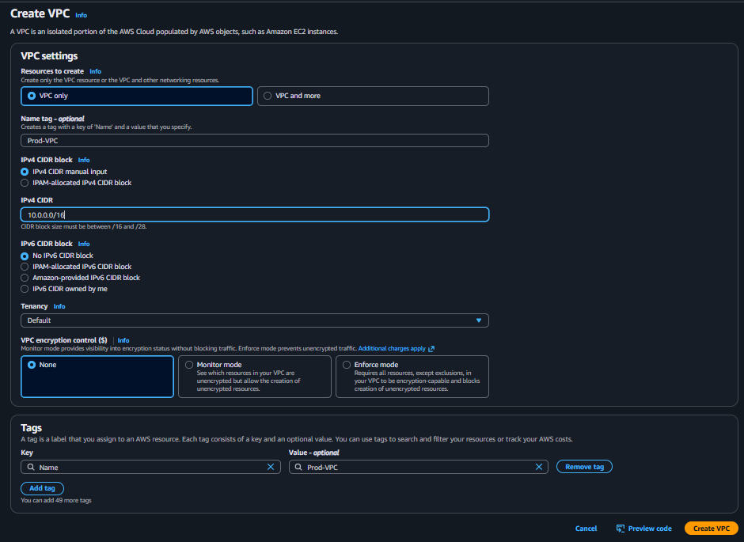
That’s it click on create vpc
Now we have our vpc
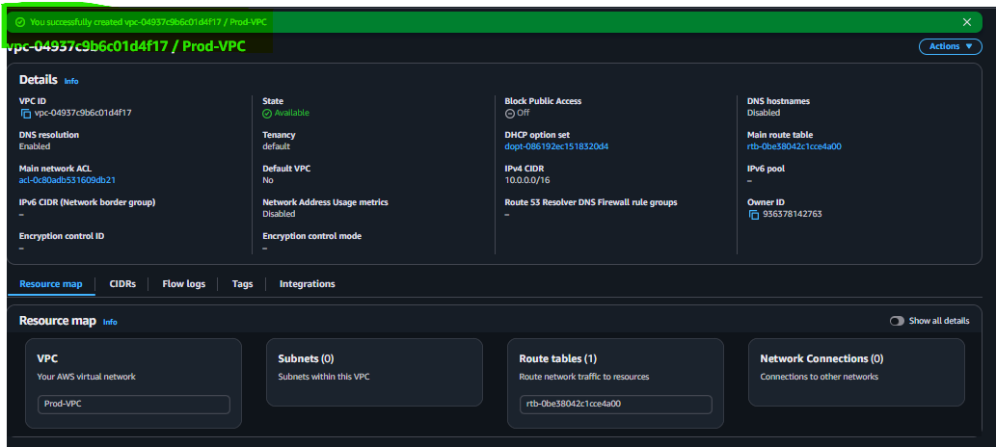

2. Create two subnets: one public subnet and one private subnet
First create public subnet click
step go to subnet section
Then click on create subnet
Then give name and ipv4 subnet cidr block then click on create subnet
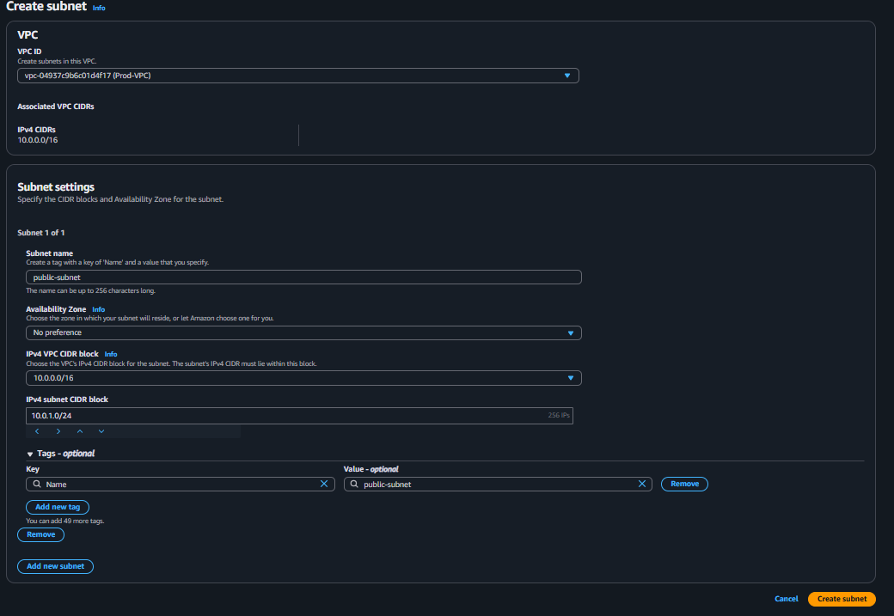
Now create our private vpc subnets follow as we follows our public but name must change and ipv4 subnet cidr then click on create subnet
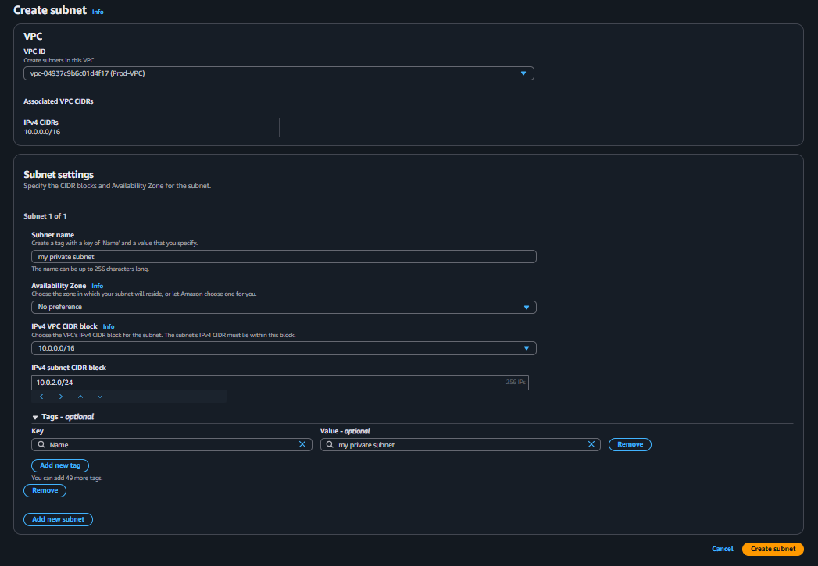

3. Attach an IGW to the VPC.
Now on table click on internet gateway then next step write internet name tag then click on create
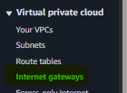
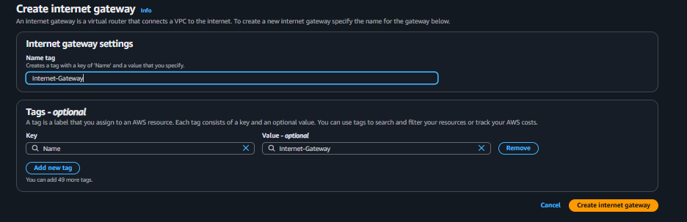
Now we have internet Gatway
4. Create one public route table (RT) and one private route table.
Now we need goes in route table section click on it create route table write name select your vpc
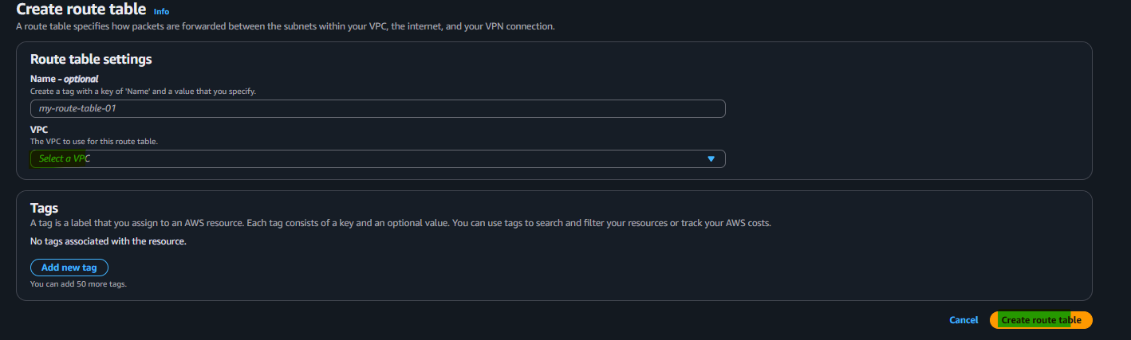
Now we have create one route table then click on edit route
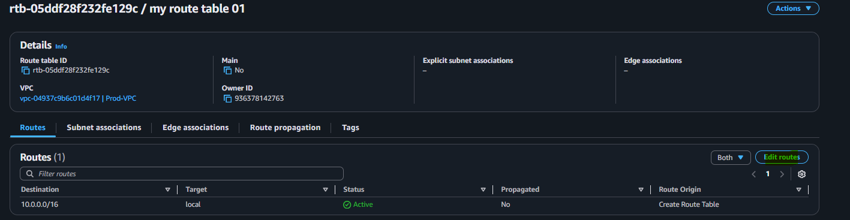
Now we type 0.0.0.0/0 and select internet gateway then click on save changes
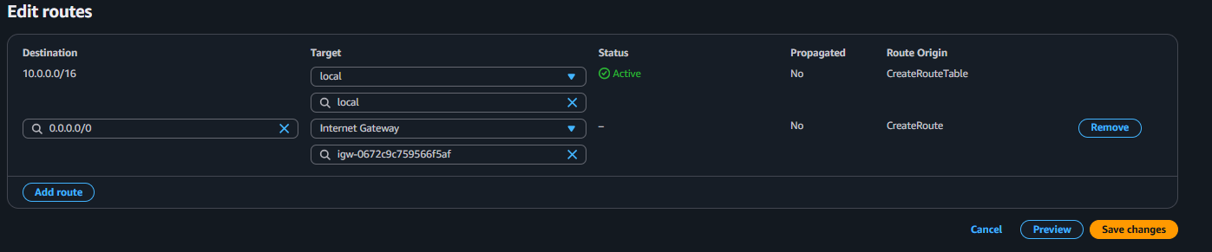
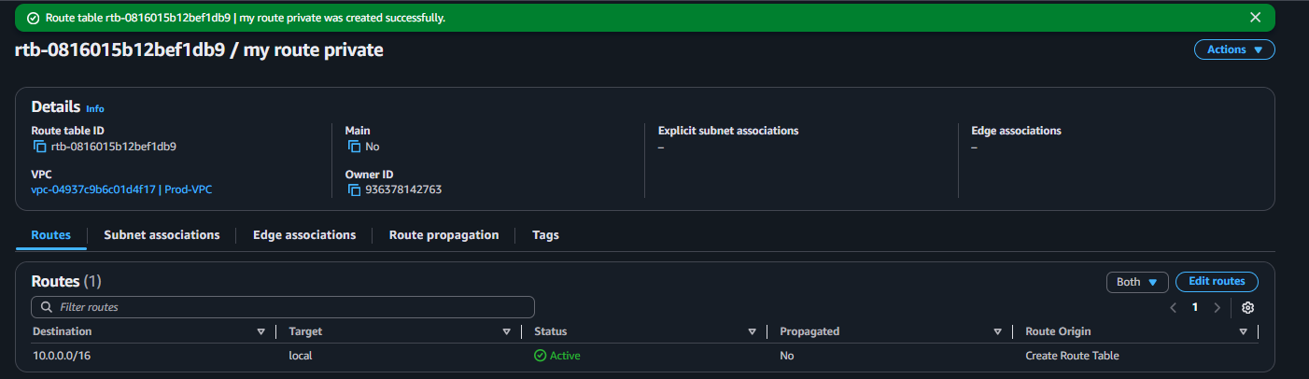
Now create nat gateway
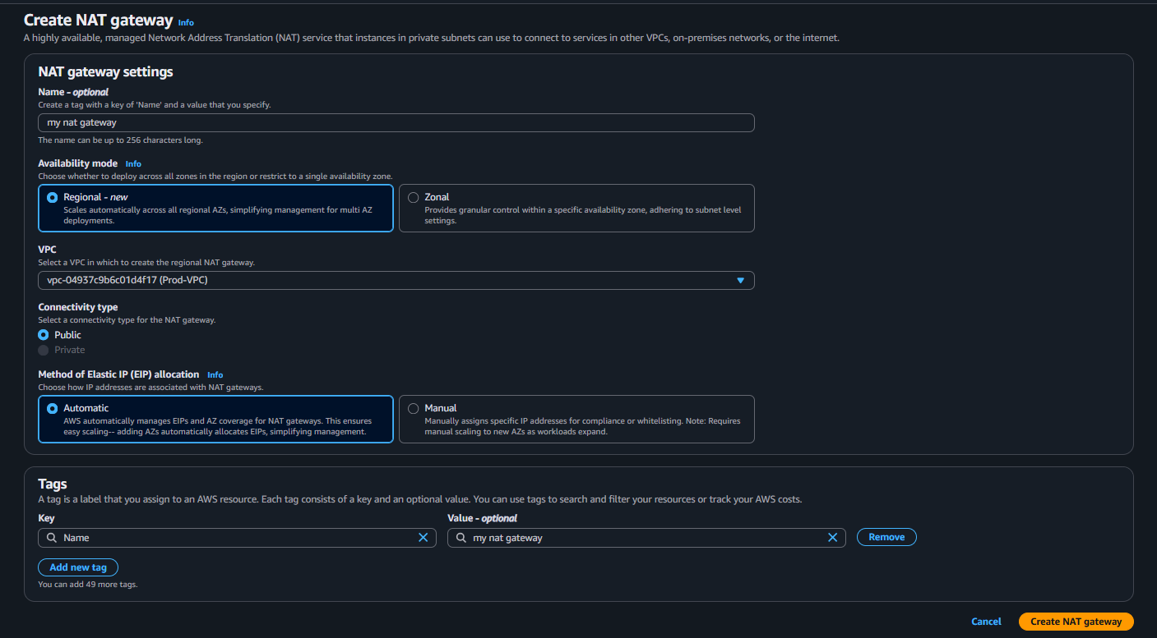
Now we have nat gateway that’s it click on save changes
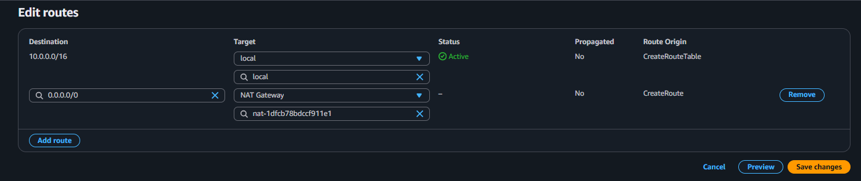

5. Deploy a NAT gateway in the public subnet and attach the NAT gateway to the private subnet.
First goes to your nat section click on create nat gateway

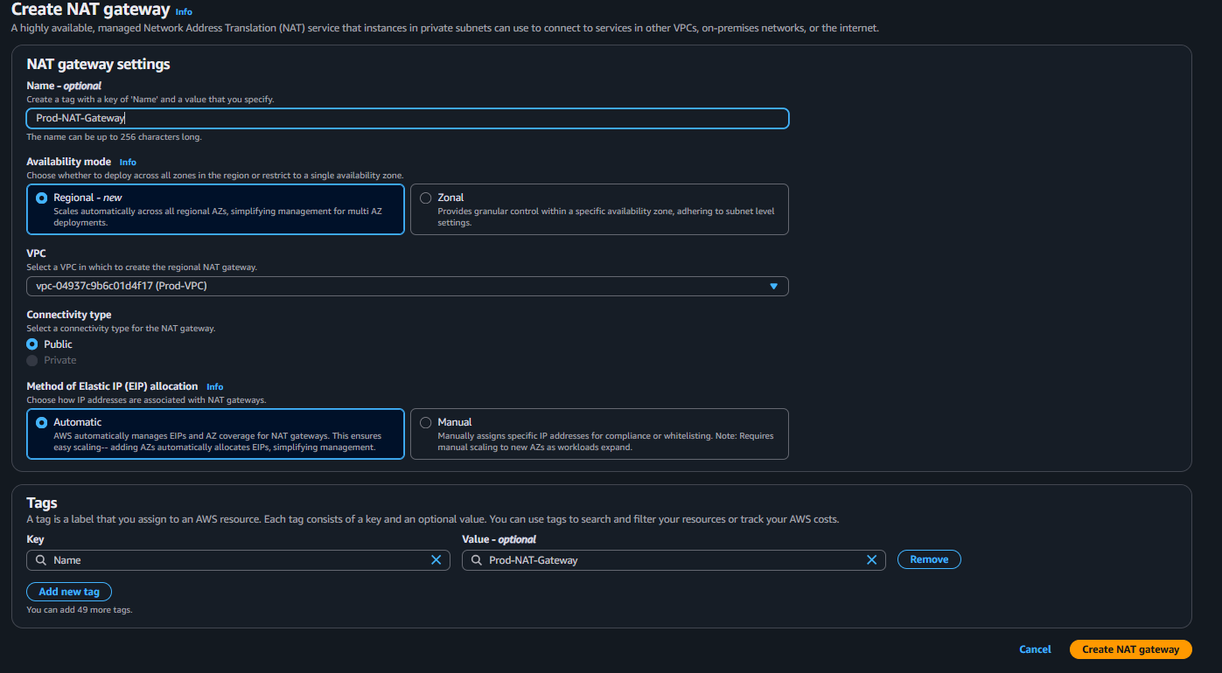
Also select allocate elastic ip address
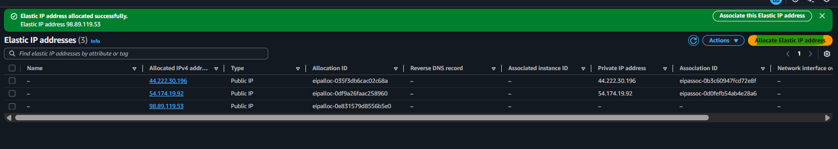

6 . Create two instances, one in the public subnet and one in the private subnet.
Now while lunching ec2 instaces you need select pulic vpc and subnet in network settings
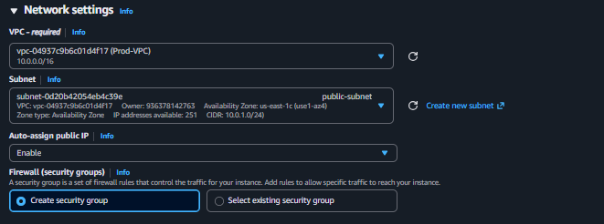
Now we have successfully lunch our public instaces
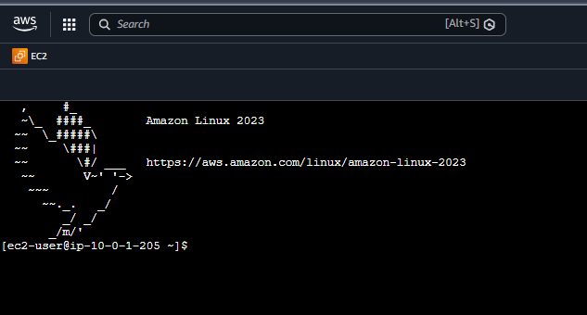
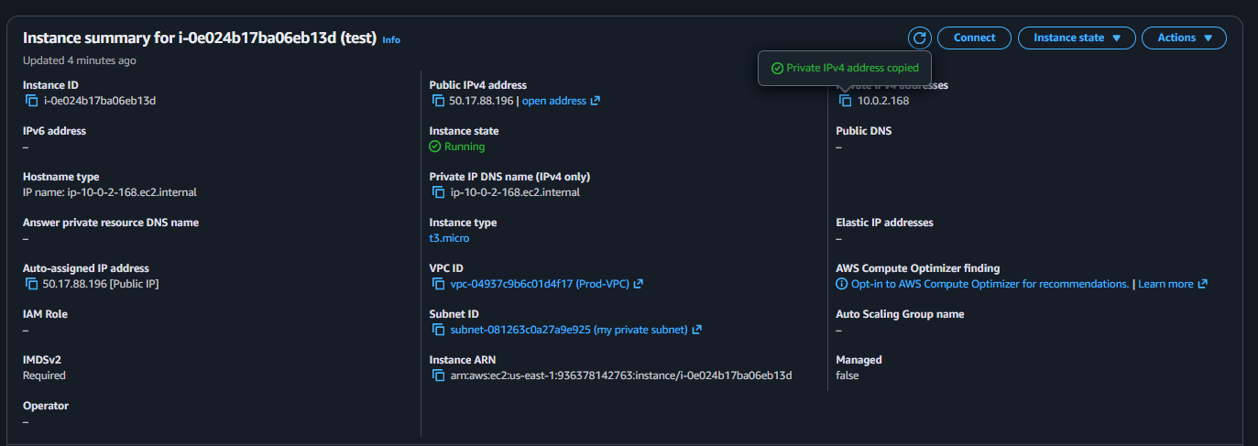

7. Deploy Apache server on both EC2 instances with a sample index.html file.
First we need Install Apache on Public EC2
Type on it sudo yum install update –y to update packages then type sudo yum install httpd –y then click on enter
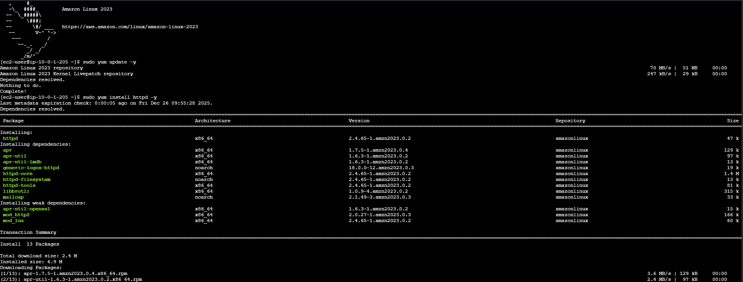
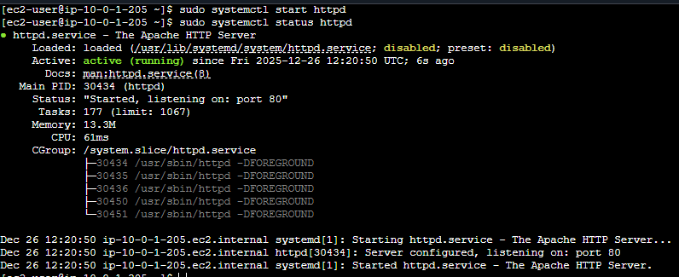
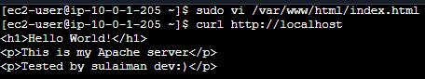
Now our index has been successfully deploit

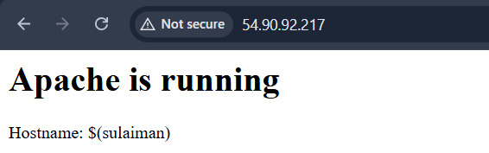

8. Create one application load balancer and attach it to both EC2 instances.
Step 1: Create Target Group
First you need go on ec2 scroll down in dashboard you find load balancers simple click on create target group
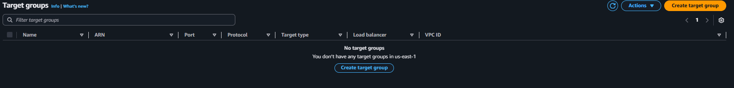

Now follow this steps
- arget type: Instances
- Target group name: tg-apache
- Protocol: HTTP
- Port: 80
- VPC: Your VPC
- Health check protocol: HTTP
- Health check path: /
That’s it click on next

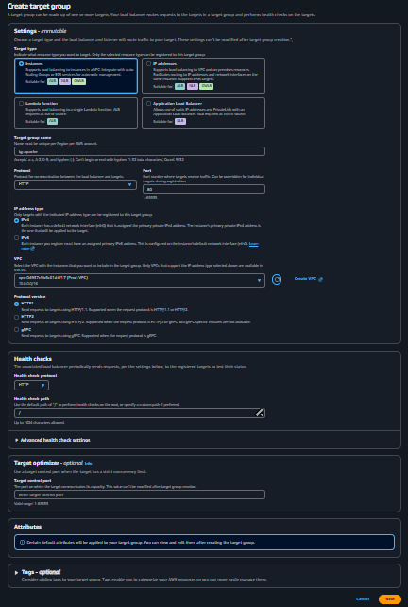
Now select your ec2 public
Now we need create load balacer
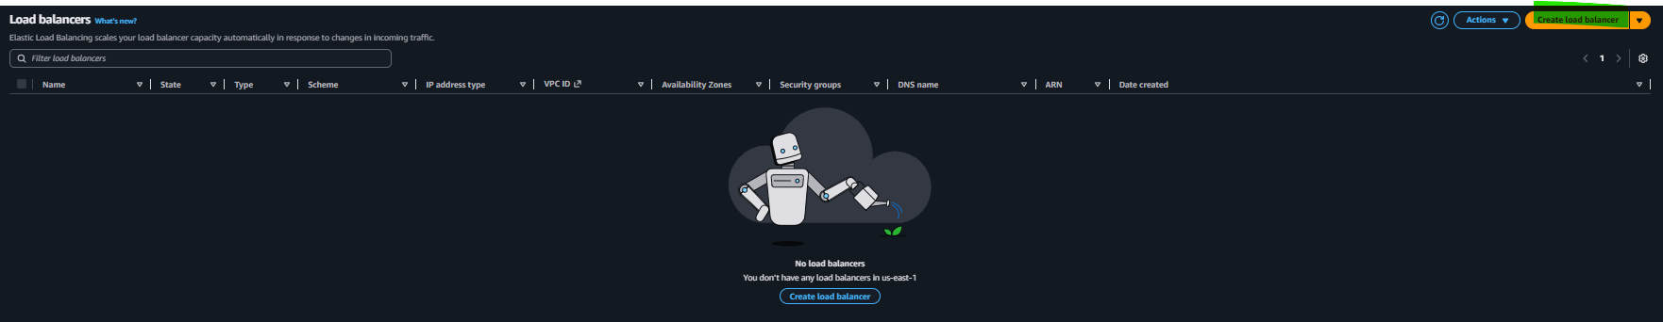
Then load balancer type at this time we selecting application load balancer then click on create

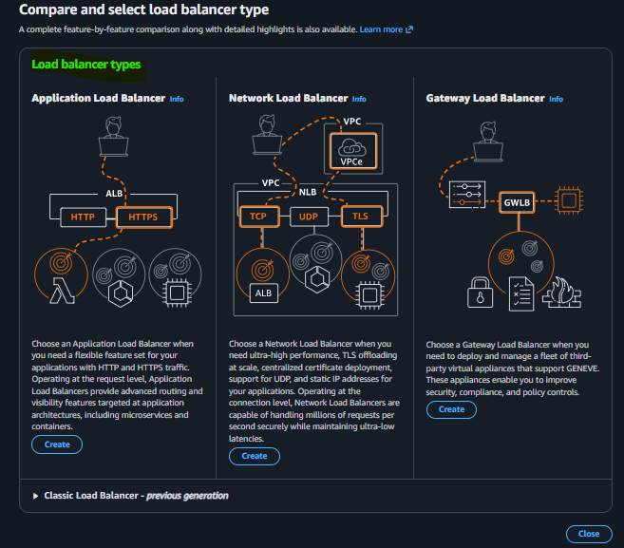

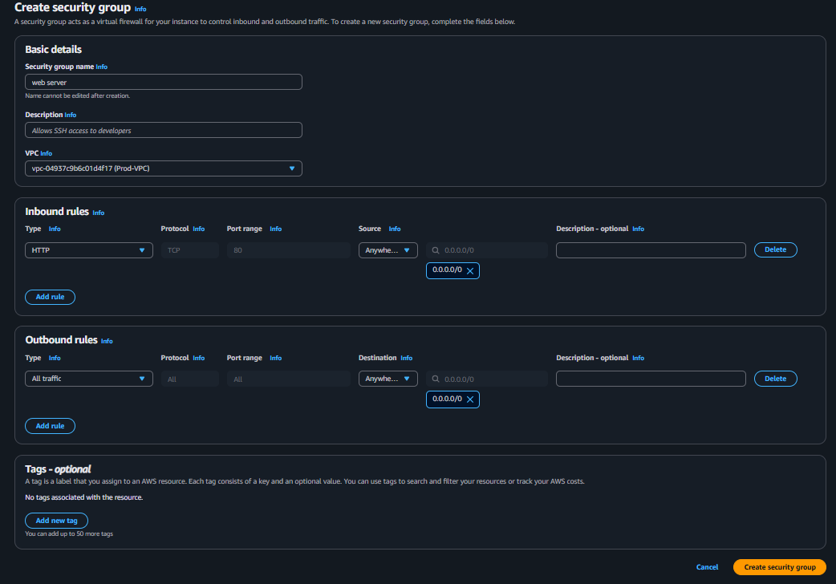

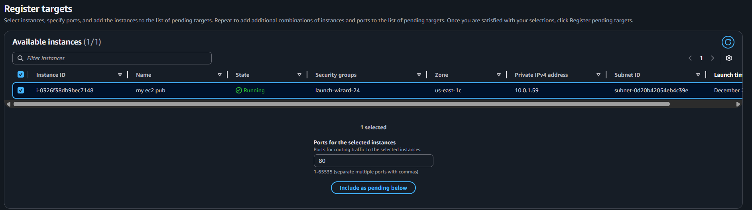
Make sure your two subnet different regions
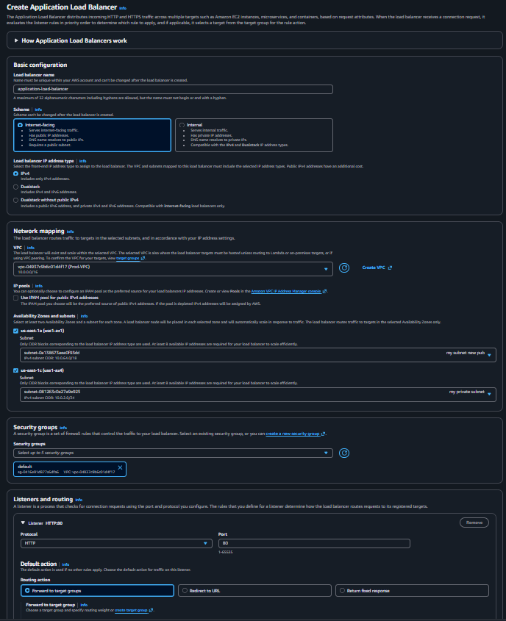

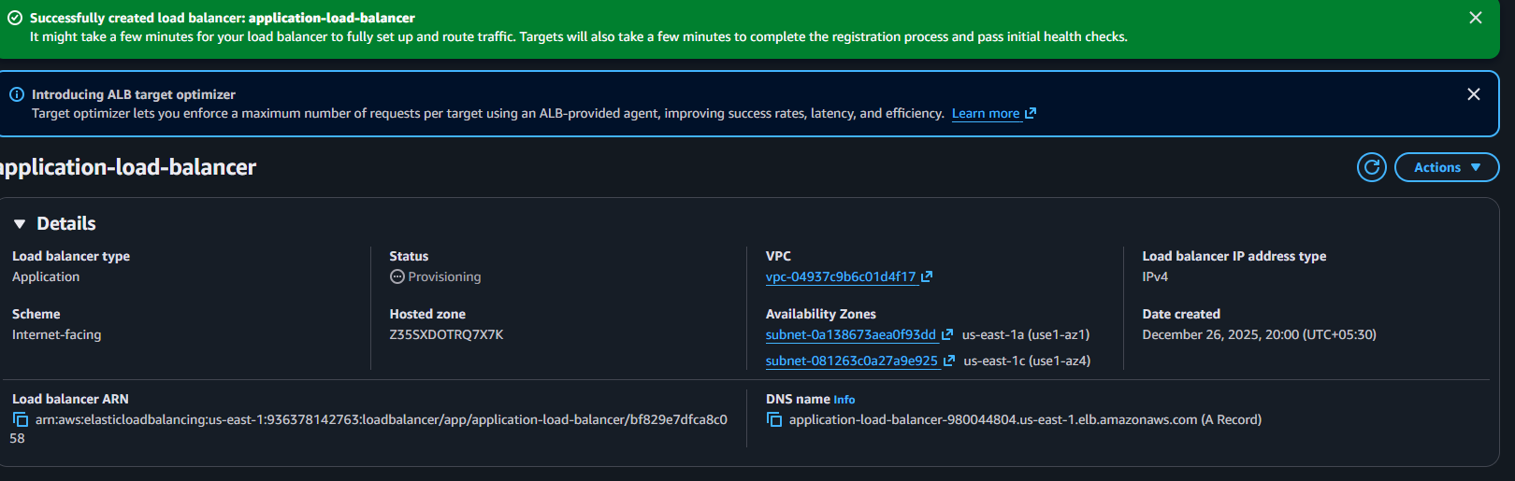
Now click on attribute
Now scroll down tick on access logs and write your bucket name after click on save changes
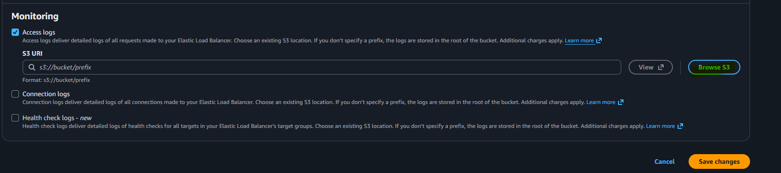
10. Store the VPC flow logs in a CloudWatch log group.
Step 1: Create CloudWatch Log Group
Evidence: Log group created
Step 2: Enable VPC Flow Logs
Traffic type: ALL
Destination: CloudWatch
Evidence: Flow logs enabled
Validation Steps
Validation 1: Log Verification
Logs visible in CloudWatch
Evidence: CloudWatch logs

After create bucket same
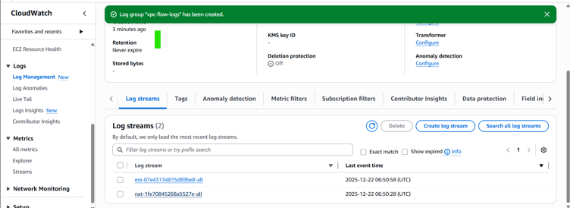

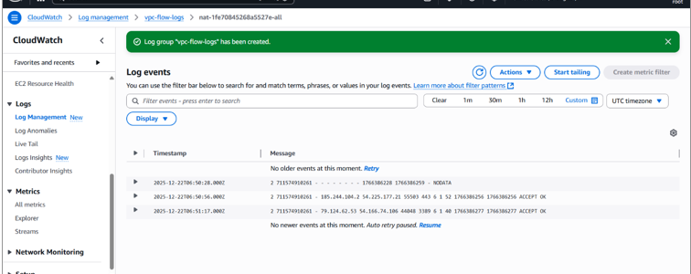
thanks for review my task

